Washington State Department of Fish & Wildlife
total:TIME – smart:Leave PILOT
System Instructions
Revision: 28 July 2026

Purpose

The leave system will provide an automated web-enabled interface by which department employees will request leave. The system will route the request to employee supervisors and allow them to approve or deny leave.

Access to the production system:
Internal URL: http://totaltime.dfw.wa.gov/totaltime/login.html
External URL: https://fortress.wa.gov/dfw/totaltime/totaltime/login.html

Access to the pilot system (Still available for further testing):
Internal URL: http://legolas.dfw.wa.gov/totaltime-test/login.html
External URL: https://test-fortress.wa.gov/dfw/totaltime/totaltime-test/login.html

smart:Leave – Entering Leave

Preferences

There are a number of users experiencing a problem with the pop-up calendar on the Leave Request screen. Until we have this problem resolved, we are turning OFF the pop-up calendar.

If you are not experiencing the pop-up problems, I encourage you to turn it on from the “Preferences” option on the “My Timesheet” tab. If you would like to turn the pop-up calendar ON, “Un-Check” the box labeled “Use text accessible calendar?”

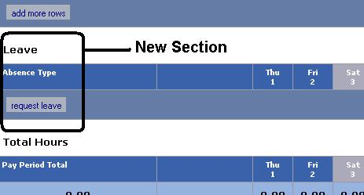
Using smart:Leave

Access the leave system by typing one of the URLs for total:TIME listed above. You will notice a new section on “My Timesheet” labeled “Leave”. This section replaces the three leave sections on the original total:TIME timesheet. The new leave section will display current leave requests. This new section is view only.

NOTE: Currently, Holiday is listed as a Leave Type in the leave system. This will be moved to the Hours Worked section of the timesheet screen since Holidays don’t require approval. Master Index will not be entered for a Holiday.

To request leave select the new “Request Leave” button in the leave section. This will take you to the new “Leave Request” screen.

LEAVE BALANCES
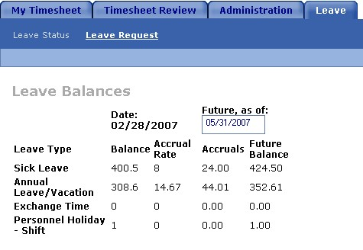
The current version of the leave balance screen is shown at the right. The leave balance grid displays the leave balance as of the last HRMS update.
This number will not reflect the latest accrual. The current accrual will be calculated based on available data (estimated). (Features to be included in the future: The current leave request column displays total hours requested and approved for the current pay-period. The current balance shows how much leave an employee will have if all leave requests are approved and processed. Current leave accruals will be calculated based on whether the accrual for the 16th of the month has occurred. Although these balances are estimated, it is our goal to make them as accurate as possible.)

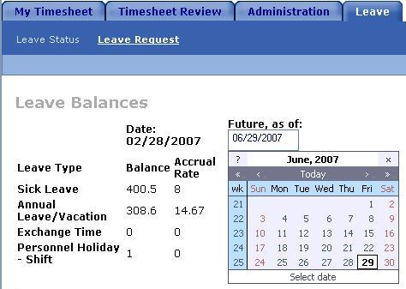
Employees also have the option of estimating leave for a future date. Clicking on the date field will bring up a calendar screen. After a date is entered into the “Future, as of” date field, the system will estimate the employees accrual rate based on the past month’s history, factor in future leave requests and estimate a future balance. This value is an estimate and may be affected by leave without pay or other factors. (Note: The pop-up calendar as shown, may not work on all computers. See the section labeled “Preferences”)

REQUESTING LEAVE

To request leave, start by entering the dates for your leave. If your leave is within a single day, you will enter beginning date and time and the ending date and time. You will also need to enter the total number of hours for this leave request. A pop-up calendar will be activated when you click on the date field. (Note: The pop-up calendar may not work on all computers and is currently disables by default. If the pop-up calendar is working on your PC you will probably want to re-activate it. See the section labeled “Preferences”)

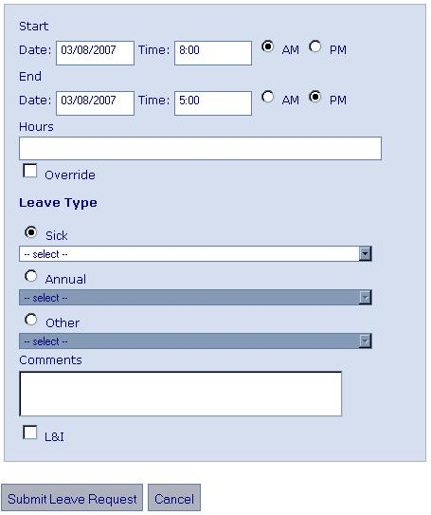
NOTE: A leave request must be a single leave type and represent a contiguous period of time.

If the dates of your leave span more than one day, a leave grid will automatically appear. Daily hours are filled in from your “standard work schedule” as defined in HRMS. If necessary, you can adjust the daily hours on the first and last day of the leave in the grid to account for partial days of leave. The middle days are read only and cannot be changed. The total number of hours in the leave grid will automatically be summed into the Hours field.

Next, select the Leave Type from one of the three pull down menus: Sick, Annual or Other. Leave types are the same as the options on the current timesheet.

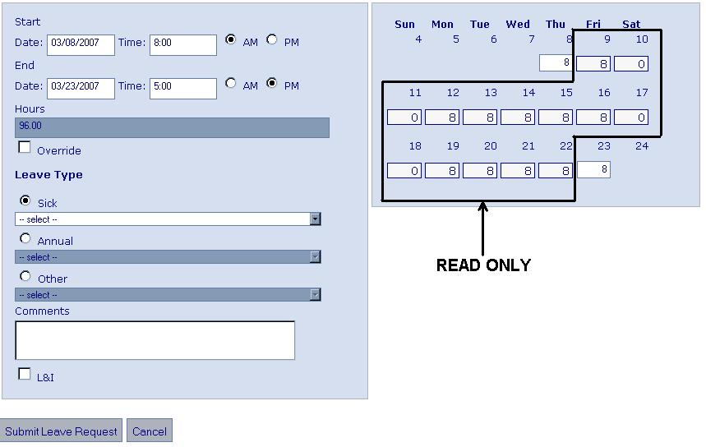
Next, click on the Submit Leave Request button to route the leave request.

NOTE: A leave request which spans multiple pay-periods will generate separate leave requests for each pay-period. The example above will generate two leave requests. One for 3/8 – 3/15 (48 hours) and another for 3/16 – 3/23 (48 hours).

(Features to be included in the future: The submit button will initiate an email to the employee’s supervisor describing the leave request along with options for approval or denial.)

NOTE: The system will not accept leave requests if the leave balance is not sufficient to support the request.

Override Option: There are situations where HRMS indicates no leave balance when an employee has actually accrued leave. If your request returns an error message indicating that you do not have leave and you feel this is in error, CONTACT YOUR PAYROLL OFFICER. Your payroll officer can approve the use of the “Override” option to address this problem.

LEAVE TAB

Once entered, the leave request will appear in the leave section of the employee’s timesheet.
The leave request will also appear on the Leave Status screen on the Leave Tab.

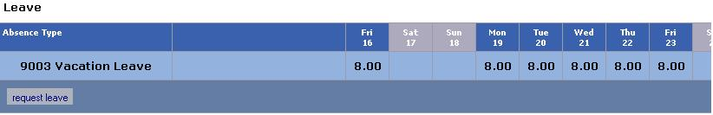
Leave requests on the timesheet are summarized by leave type, one line for each leave type. Individual leave requests are listed on the Leave Status screen by request.

Employees can view the status of their leave request from the Leave Status screen. An employee can edit or cancel a leave request at any time. An Edited leave request will replace the original request (Features to be included in the future, Email Notification: The supervisor will be notified of the change through the email notification system. Canceling an approved request will also generate an email to the supervisor).

The statuses of leave requests are “Pending” (submitted by the employee), Approved (approved by a supervisor), Cancelled (cancelled by an employee) and Denied (denied by a supervisor).

You can also initiate a new leave request from the Leave Status screen by clicking the Leave Request button.

SUPERVISORS ONLY -- Leave Approval

Supervisors may approve leave from the Leave Approval option on the Timesheet Review tab. The Leave Approval screen will display all leave requests that currently require action. This list will include requests from the supervisor’s employees and any employees that the supervisor has proxy rights to approve.
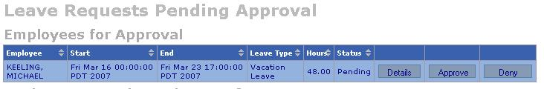
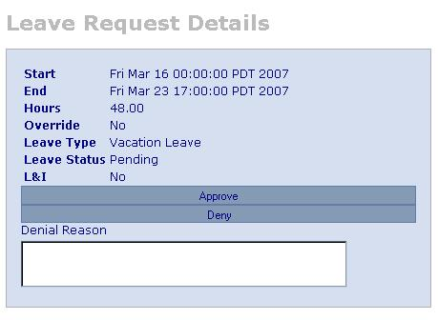
The supervisor has the option of approving or denying the leave. (The Details button will display leave request details and allow the supervisor to approve or deny a leave request.) The Approve button approves the leave request with no other action required. If a request is denied, either from the Details screen or from the Deny button, the system requires a message stating the reason for denial.

(Features to be included in the future: The supervisor will also receive an email from the system for each leave request. The email will have options to approve or deny the request directly from the message (password is required). Again, a message is required in the case of leave denial.)

